The 14th Poster Presentation of Science and Technology Science
Beijing Normal-Hong Kong Baptist University (2026)

General Guidelines for Poster Preparation

Please observe the following guidelines when preparing your poster:

- Your poster should be prepared in portrait orientation with dimensions 1.4 m (H) × 0.9 m (W).
- Place the title in the top center of the poster (font size 72, Arial, in bold).
- The title banner should be 0.9 m wide.
- The names of the authors should be placed below the title (font size 44, Arial, in bold).
- Author’s affiliations and e-mail addresses should be included (font size 44, in Italic).
- Smaller fonts may be used in the citations and acknowledgements.
- Visual impact is important and you are encouraged to include color images and background.
- Text: a poster should be easily readable from a distance of 1–2 meters. Line spacing should be 1.5 lines. Authors should also pay attention to the following points:
  - Headings should be larger than normal text (font size 40, Arial, bold or other colors may be used).
  - Subheading (if applicable): font size 36 (Arial, bold)
  - Body of text: font size 24 (Times New Roman, normal)
  - The amount of text should be kept to a minimum
- Use the color of your own programme for poster title:
Programme | RGB reference
Artificial Intellegence: Medium Blue | 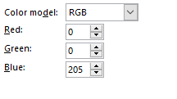  
Applied Mathematics: Orange | 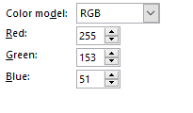  
Applied Psychology: Pink | 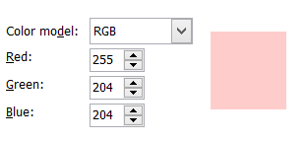
Computer Science and Technology: Light blue | 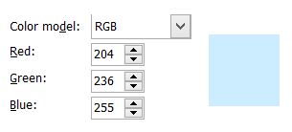
Data Science: Turquoise | 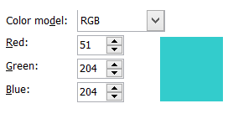
Environmental Science: Green | 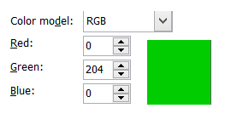
Financial Mathematics: Brick brown | 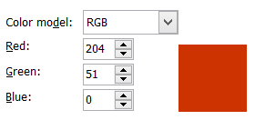
Food Science: Yellow | 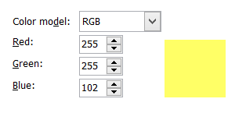
Statistics: Light purple | 